**DATA VISUALIZATION PROJECT REPORT**

(Project Semester August-December 2024)

***DASHBOARD ON ANNUAL SALES REPORT***

Submitted by

Raman Goyal

Registration No 12216883

Programme and Section K22GX

Course Code INT233

Under the Guidance of

**Ashu 23631**

**Discipline of CSE/IT**

**Lovely School of Computer Science**

**Lovely Professional University, Phagwara**

**CERTIFICATE**

This is to certify that Raman Goyal bearing Registration no. 12216883 has completed INT 233 project titled, **“Dashboard on Annual Sales Report”** under my guidance and supervision. To the best of my knowledge, the present work is the result of his original development, effort and study.

**Signature and Name of the Supervisor**

**Designation of the Supervisor**

**School of Computer Science**

Lovely Professional University

Phagwara, Punjab.

Date: 20th November, 2024

**DECLARATION**

I, Raman Goyal, student of Computer Science and Engineering under CSE/IT Discipline at, Lovely Professional University, Punjab, hereby declare that all the information furnished in this project report is based on my own intensive work and is genuine.

Raman Goyal

Date:20th November, 2024 Signature

Registration No. 12216883 Name of the student

**Annual Sales Analysis Report**

**1. Executive Summary**

This report presents an in-depth analysis of store sales data, offering insights into state-wise sales, gender-based sales forecasts, category preferences, and channel-wise performance. Utilizing Tableau, we designed a dashboard to visualize the sales dynamics and growth patterns, aiding strategic decision-making.

**2. Objectives**

* Analyze sales trends across regions and channels.
* Identify key product categories driving revenue.
* Predict gender-based sales trends and highlight growth opportunities.
* Offer actionable insights for improving sales performance.

**3. Data Overview**

**Dataset Details**:

* **File Name**: Vrinda_Store_Data.xlsx
* **Dimensions**: States, Categories, Channels, Gender
* **Metrics**: Sales Amount, Forecasted Sales, Growth Trends

**Key Variables**:

* **Product Categories**: Kurta, Saree, Western Dress, Top, Set
* **Sales Channels**: Amazon, Myntra, Flipkart, Meesho, Others
* **Geographical Coverage**: Sales across 30 Indian states and union territories
* **Gender**: Male and Female sales segmentation

**4. Visualizations and Analysis**

1. **State-wise Sales Distribution**
   * **Visualization**: Interactive map (from Tableau dashboard)
   * **Key Insight**:
     + Maharashtra dominates sales with ₹29,90,221, followed by Karnataka (₹26,46,358) and Uttar Pradesh (₹21,04,659).
     + States like Haryana and West Bengal have lower contributions but show potential for growth.
2. **Category-wise Sales**
   * **Visualization**: Bubble chart
   * **Key Insight**:
     + The highest revenue is generated from *Set* (₹1,05,07,546), followed by *Kurta* (₹49,59,377).
     + Saree and Western Dress collectively account for significant contributions to total sales.
3. **Channel-wise Sales**
   * **Visualization**: Donut chart
   * **Key Insight**:
     + **Amazon** leads as the top-performing channel with ₹75,19,933, accounting for 35% of total sales.
     + **Myntra** (₹49,41,540) and **Flipkart** (₹45,73,301) are strong competitors, while Meesho and others have smaller shares.
4. **Gender-based Sales Forecast**
   * **Visualization**: Line chart
   * **Key Insight**:
     + Women consistently outperform men in sales revenue, with a forecasted total of ₹11,22,232 in May 2023, compared to ₹6,01,256 for men.
     + Growth is steady for both genders, highlighting an opportunity to expand targeted campaigns.
5. **Top 10 States Sales Trends**
   * **Visualization**: Bar and line chart
   * **Key Insight**:
     + Maharashtra's lead in sales volume is complemented by strong performances in Karnataka and Uttar Pradesh.
     + Sales in Andhra Pradesh and Haryana remain relatively lower, presenting an opportunity to target these regions with promotional efforts.

**5. Key Insights and Recommendations**

1. **Focus on High-performing States**:
   * Continue investing in Maharashtra, Karnataka, and Uttar Pradesh as they drive the majority of revenue.
   * Develop state-specific strategies for regions like Haryana, West Bengal, and Andhra Pradesh to enhance their sales potential.
2. **Optimize Product Offerings**:
   * Promote top-performing categories like *Set* and *Kurta* to maintain dominance.
   * Encourage cross-selling of lower-performing categories such as Western Dress and Saree.
3. **Channel Strategy**:
   * Strengthen collaborations with Amazon, Myntra, and Flipkart to sustain growth.
   * Explore opportunities to boost sales via emerging channels like Meesho.
4. **Gender-based Campaigns**:
   * Target women-focused products and promotions to capitalize on their higher sales trends.
   * Consider expanding product lines for men to balance the sales contribution.

**6. Conclusion**

This report demonstrates how Tableau dashboards can simplify complex datasets into actionable insights. By focusing on high-performing regions, leveraging strong channels, and promoting trending categories, businesses can ensure sustained growth.

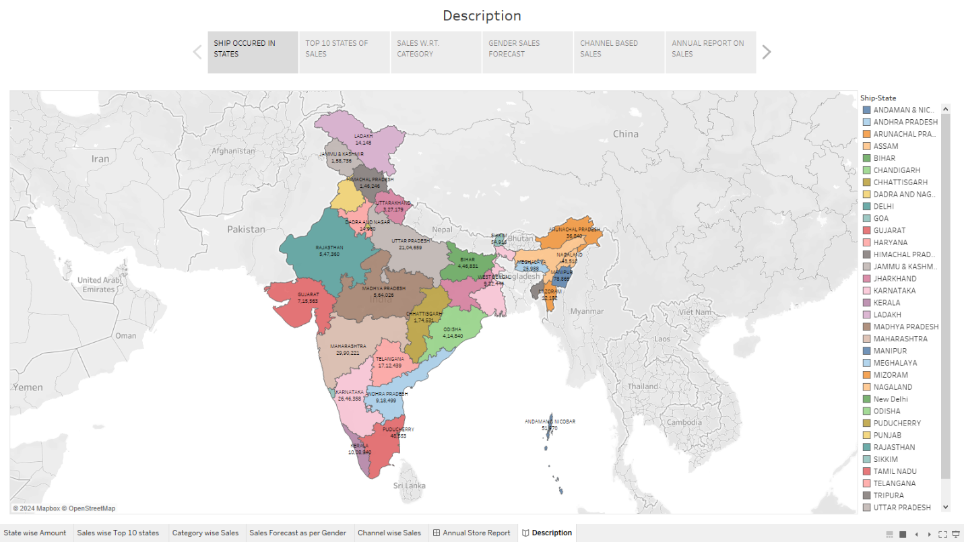

A chart showing ship states along with sales

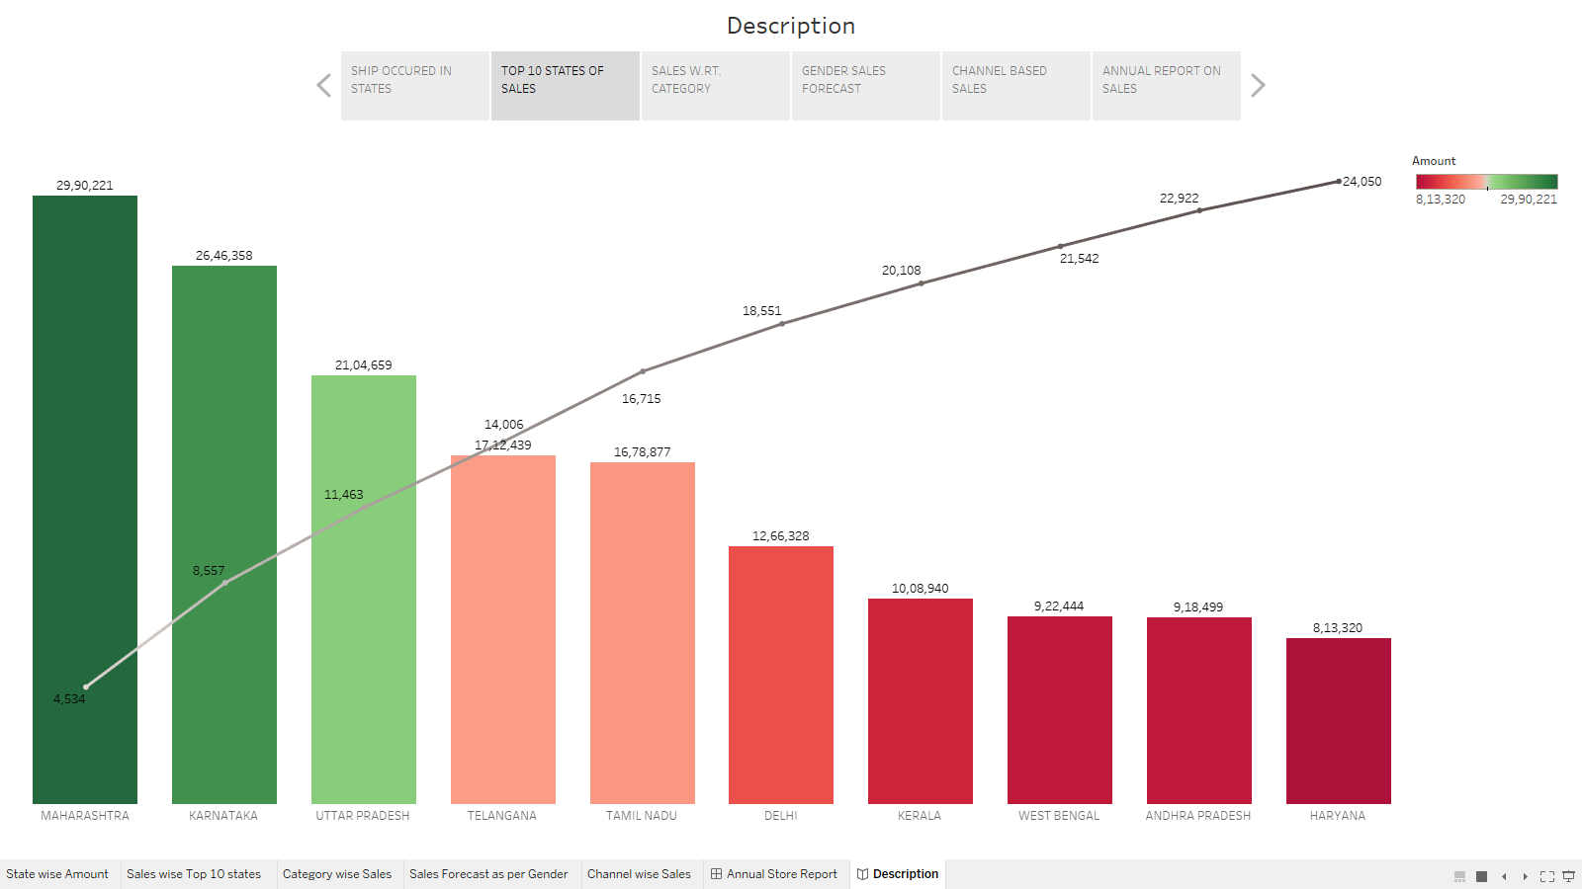

Chart showing top 10 states with sales and quatity

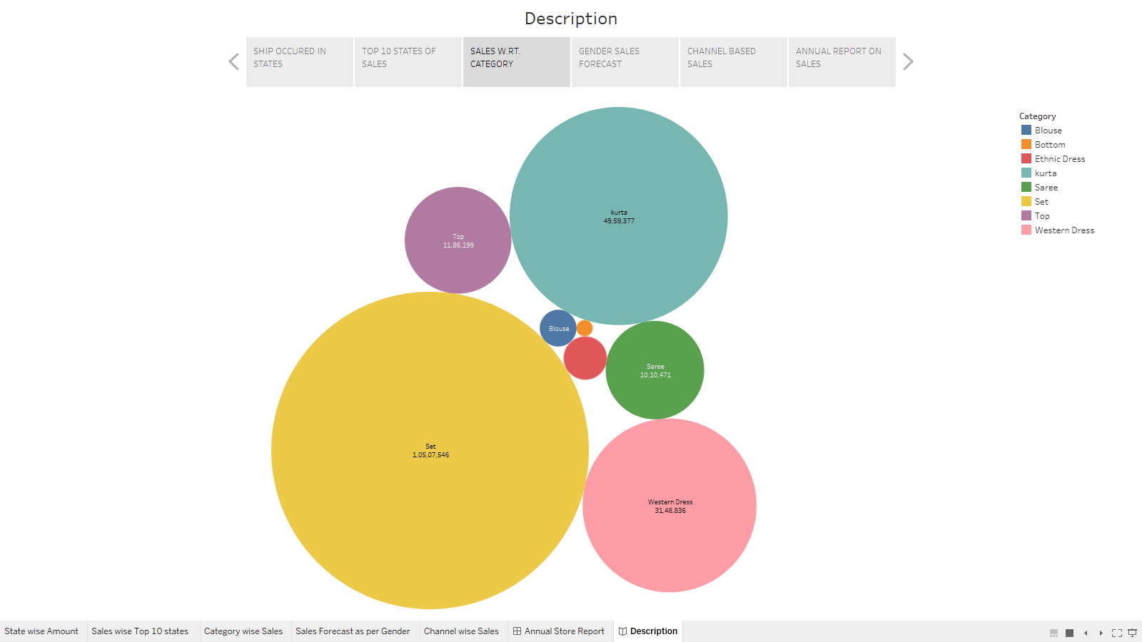

Sales total category wise

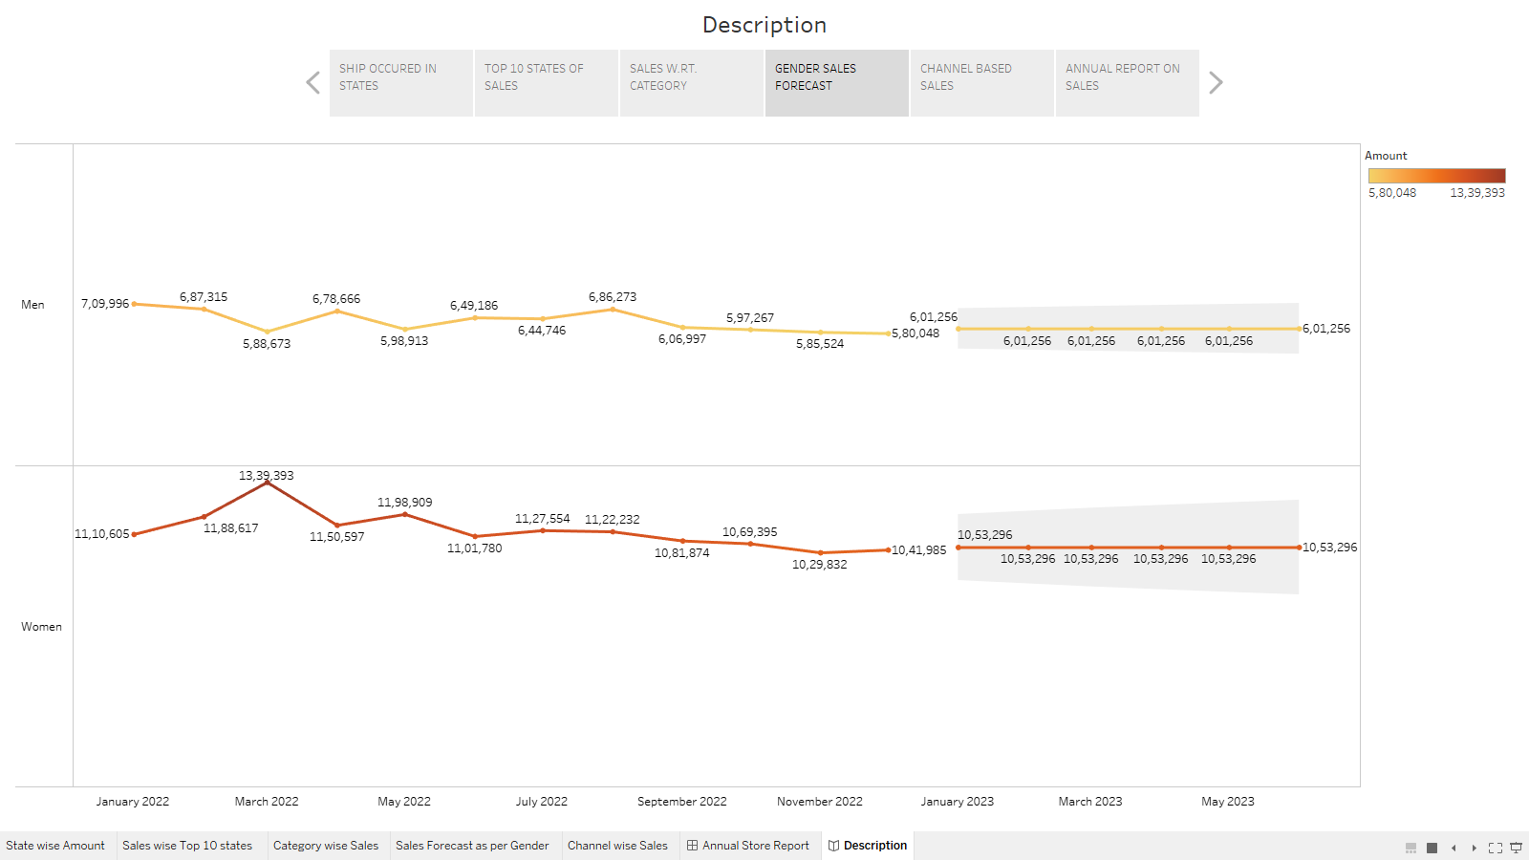

Gender wise month on month sales and forecast for next 6 months

Channel wise sales total

